CDM EB Side Event at COP26
Speaker Bio
Wednesday, 3 Nov. 2021, 18:30—19:45, Clyde Auditorium (also virtual)
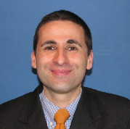
Olivier Kassi, who joined the Board in 2013, is the Climate and Carbon Market Advisor at the Walloon Air and Climate Agency. He is the Chair of the CDM Executive Board. He holds higher degree in Engineering and Management. Olivier has more than 15 years of experience in climate change policy and carbon markets at regional, national, European and international levels.

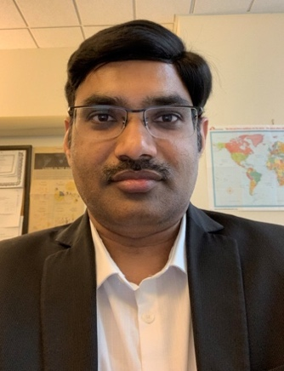
Hari Gadde is a Senior Climate Change Specialist in the Carbon Markers and Innovation practice of the Climate Change Group in the World Bank. He has been working on climate change related issues, especially on carbon markets and carbon pricing for more than 15 years. He is one of the leading members of the Article 6 work program for piloting next generation of carbon market concepts in the World Bank and leads the development of Approach Papers of the Article 6 Warehouse program and the digitalization of MRV systems. He is also coordinator for the technical work program of the Partnership for Market Implementation (PMI) and leads the Standardized Crediting Framework implementation under the Carbon Initiative for Development (Ci-Dev).

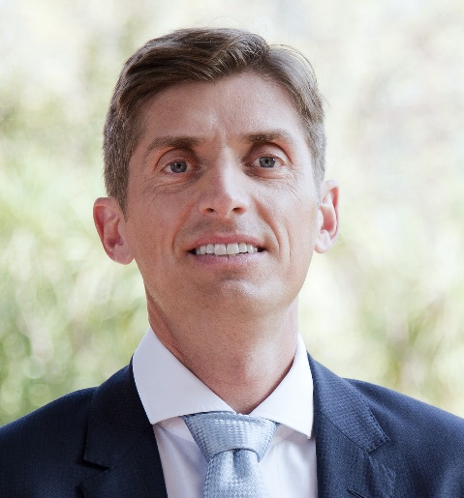
Florian Eickhold is the Climate Finance and Environmental Markets Expert at atmosfair. He holds Diploma in Latin American Studies. He has over 15 years’ experience with the development of climate policies and solutions. After graduating as Scientist of Latin American Studies at the University of Cologne focussing in his education on environmental economics and international politics, he started to work on international climate change projects. Now he designs sustainable carbon market and climate finance projects and innovates key elements of corporate or public climate change strategies. At atmosfair he leads the negotiations with host countries on corresponding adjustments and strategic developments for a “Paris-aligned” Voluntary Carbon Market.

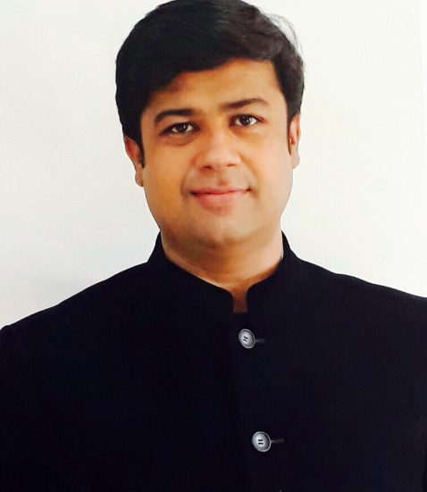
Hitesh Goyal is the representative of Nature Club of Rajasthan – an Action Group For Nature Conservation, which is the Coordinating/Managing Entity for PoA 10516: Improved cook stoves and sustainable charcoal initiative.

Having spent the past 12 years working in the voluntary and compliance carbon markets and climate policy thought leadership, Marco Magini holds the role of Director Projects and Portfolio Management. With practical experience in carbon project development, implementation and trading, Marco is passionate about placing innovation and partnership at the heart of our climate projects. The team currently manages more than 300 projects worldwide and it consists of a team of more than 200 experts around the globe. Marco graduated in International and Economic Policy from the London School of Economics.

----------------------

