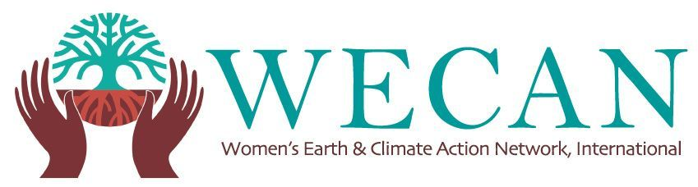
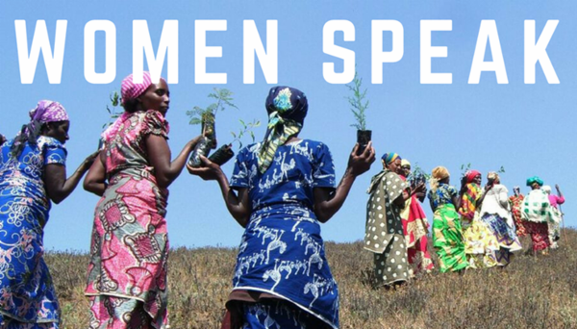
http://wecaninternational.org/womenspeak

A robust online research and storytelling database, 'Women Speak: Stories, Case Studies And Solutions From The Frontlines Of Climate Change', is available to all as a critical tool for frontline leaders, policy makers, journalists, activists, educators, students, and all those seeking to understand and demonstrate why and how women are paramount to just action on the climate crisis.

The 'Women Speak: Stories, Case Studies and Solutions From The Frontlines Of Climate Change' database and initiative has been designed and compiled by the Women's Earth and Climate Action Network (WECAN) International in order to shift the narrative on gender, feminist analysis and climate, and to challenge dominant systems of exploitation and oppression of women and the Earth, as we collect and share thousands of stories by and about women leading struggles and solutions for climate justice under a variety of cross-sectional themes, such as forest and biodiversity protection; fossil fuel resistance efforts; ecologic agriculture and land rights protection; renewable energy implementation; climate law and policy; education and grassroots movement building; and much more. The goal is to create an accessible and ever-growing source of information, research and multimedia storytelling.

The database responds to an urgent need, identified by WECAN International and many diverse groups worldwide, for a compilation of qualitative evidence, and a readily accessible and expanding repository of examples of feminist analysis and women's actions for climate justice and solutions.

Despite the fact that women are impacted first and worst by climate change, and have proven to be central to successful climate solutions and policies, the voice and rights of women often continue to be suppressed and ignored. As CNN and Media Matters have reported, only 15% of those interviewed in the media on climate change have been women.

In the face of the hottest temperatures ever recorded, the displacement of millions around the world, and the devastating impacts of environmental degradation on the Earth and our diverse communities – the most pressing story that needs to be heard is that of women on the frontlines of climate change. Studies worldwide demonstrate that women must be engaged at all levels of participation, leadership and decision-making to build effective and just social and ecological programs and communities.

With a thousand entries already reviewed and uploaded, we aim to build a living repository online of existent articles, case studies and emerging stories. Quantitative and qualitative data – in the context of stories that deeply define and narrate women’s leadership and their climate solutions - will be continually collected.

APPLICATIONS OF WOMEN SPEAK PROJECT:
1. Policy making as well as policymakers

It is important to use the repository to reach out to leaders who are unaware of these key efforts by women so they can assimilate the results of successful efforts, leadership and models of sustainability -- with a particular emphasis on climate justice and steering clear of false solutions through documented case studies. We believe bringing together different constituencies at different levels through case studies and on-the-ground solutions will have pivotal results.

2. Funding

Leveraging the story of women’s voices and on-the-ground projects that are already underway can significantly influence funding for women-led solutions and projects. Research shows less than 2 percent of all philanthropic dollars goes to climate change. Of that 2 percent only a small fraction of that funding goes to women working in environmental fields. Clearly there is an enormous gap between the successful outputs that women are achieving and the availability of funding for their future success. Demonstrating successful case studies and solutions examples have not surfaced enough to penetrate these funding streams – Women Speak seeks to help close this gap.

3. Educational Institutions

Due to status quo literature, which currently has an under-representation of women’s leadership, there is a great need to demonstrate women as solution bearers and leading change makers in the environmental arena. Women Speak is pivotal not only for educational purposes among institutions but also to encourage young women by presenting powerful role models of the courage and brilliance of women leading efforts to solve the climate crisis.

4. Visibility, protection, increased funding and policy influence for Women Land and Climate Defenders

Throughout the world, hundreds of women environmental activists have been jailed, attacked and defamed as threats to "national security". They remain without adequate visibility, resources, protection and funding for their work. Women comprise the majority of the world’s poor and experience systemic marginalization, discrimination, and violence. This makes them particularly vulnerable to the effects of climate change and environmental degradation. When they mobilize for environmental rights they face myriad obstacles, both because of their activism and because they are women. By telling their stories the WECAN Women Speak Project can work to support protection for women on the frontlines of climate change.

5. Journalists

Communicating new narratives, case studies, on-the-ground solutions and resistance efforts at the local, national and international levels through journalistic avenues can affect public policy, funding and access to resources and decision makers.

